Business Risks in AI Sentiment Analysis
Abstract
With the widespread adoption of artificial intelligence in business, sentiment analysis models are increasingly used to automate the interpretation of the "Voice of the Customer" (VoC). This study aims to evaluate the practical utility and potential risks of advanced pre-trained language models, represented by DistilBERT, when processing real-world consumer reviews. By fine-tuning a three-class sentiment model based on the Amazon Food Reviews dataset (N>1000), we achieve an impressive macro-accuracy of 90%. However, an in-depth analysis of the confusion matrix reveals critical deficiencies: the model exhibits a complete failure to identify neutral sentiment and misclassifies a significant portion of negative reviews as positive. To find out the model's decision-making logic, KeyBERT was employed for keyword extraction. The findings suggest that the model's limitations stem from an insufficient grasp of context and complex semantics, such as sarcasm. This report demonstrates that a singular focus on high-level accuracy metrics creates an "illusion of understanding," bringing significant misjudgment risks for businesses reliant on AI-driven automation. Finally, a "Human-in-the-Loop" analytical framework is proposed to compensate for the model's shortcomings and enable a more accurate distillation of actionable business intelligence from consumer feedback.
1. Introduction
1.1 Research Background
In the digital economy, businesses face a huge amount of unstructured user data, of which online consumer reviews have become an important source of intelligence for marketing insight, product development, and brand reputation management. The effective analysis of "Voice of the Customer" (VoC) is the key factor of gaining a competitive edge. Pre-trained language models (PLMs) such as BERT (Devlin et al., 2019) and its efficient variant, DistilBERT (Sanh et al., 2019), have emerged as the dominant technology in the sentiment analysis domain due to their powerful language comprehension capabilities, and are widely regarded as the ideal tools for automating VoC analysis.
1.2 Research Aims and Questions
This study aims to explore the potential gulf between a model's statistical performance on benchmark datasets and its practical utility in real-world business applications. We critically evaluate the real-world utility of a DistilBERT-based sentiment analysis model through a concrete case study, and try to propose in-depth methods for mining insights that go beyond simple categorization.
The research is guided by the following core questions:
- Where are the performance boundaries of a DistilBERT model that performs well in benchmarking when faced with real user comments of sarcasm, implicit complaints and complex emotions? How reliable are its decisions?
- What are the main areas of classification error in the model? How do these "technical errors" translate into "business risks"?
- In addition to quantitative classification, can we use other NLP tools to assist in understanding model behavior and extract more valuable business insights?
1.3 Report Structure
This report will first review the application of sentiment analysis techniques in business intelligence and the development of related models. Then, we will illustrate the data sources, preprocessing, model creation and training details, as well as the evaluation methods combining quantitative and qualitative in this study. The experimental results are then presented and analyzed, focusing on the classification flaws behind the model's high-precision metrics. In the discussion section, this report will discuss the business risks and strategic opportunities implied by these technical limitations, and analyze the limitations and future prospects of this study.
2. Literature Review
Sentiment analysis, also known as opinion mining, aims to automatically identify and extract subjective information from text. As an important branch of Natural Language Processing (NLP), its development is closely linked to business needs. Early sentiment analysis relied heavily on sentiment dictionaries and traditional machine learning methods (e.g., support vector machines), which are effective but have limited ability to understand complex syntax and context. In recent years, deep learning, particularly pre-trained language models (PLMs) based on the Transformer architecture (Vaswani et al., 2017), has brought a revolution in this field.
The BERT model, which is able to capture deep context information through its bi-directional encoder structure and pre-training on large-scale corpora, has achieved breakthroughs on various NLP benchmark tests. However, the large model size and high computational cost of BERT limit its deployment in many real-time business scenarios. As a response, DistilBERT has succeeded in significantly reducing model size and improving inference speed while retaining about 97% of BERT's performance through knowledge distillation, making it an industrial solution that keeps an excellent balance between performance and efficiency.
With the rapid changes in technology, critical reflections on the evaluation of AI models have begun to emerge in academia. Some researchers have pointed out that single macro-metrics (e.g., accuracy) may mask systematic biases in key subsets of models, especially when dealing with social biases, adversarial attacks, or minority data (Raji et al., 2021). This "illusion of high accuracy" can lead to serious consequences in high-risk decision-making domains, as well as to strategic miscalculations in business domains. Therefore, it is at the intersection of this technological background and critical thinking that this study attempts to empirically test a NLP model closer to real-world applications.
3. Methodology
This study employs a mixed-methods approach, combining quantitative performance evaluation with qualitative thematic analysis to assess the model's capabilities and limitations.
3.1 Dataset
The data for this study was the publicly available Amazon Food Reviews dataset (Reviews.csv). A subset of 1,000+ reviews was randomly sampled for rapid prototyping and analysis.
3.2 Data Preprocessing
The preprocessing involved several key steps:
- Text Aggregation: The Summary and Text of each review were zipped to form a single, comprehensive text input, ensuring all available information was captured.
- Label Mapping: The original 1 to 5 Score was converted into a three-class sentiment label. Scores of 1-2 were mapped to Negative (0), a score of 3 to Neutral (1), and scores of 4-5 to Positive (2).
- Data Splitting: The dataset was randomly split into a training set (800+ samples) and a validation set (200+ samples) in the ratio of 80:20 for model training and evaluation.
3.3 Model Creation and Training (see sclassif.py for details)
- Model Creation：The DistilBERT model was loaded from the Hugging Face Transformers library. We added a fully connected layer with three output units, corresponding to negative, neutral, and positive sentiment classes.
- Training Process: The model was fine-tuned for EPOCHS = 2 full passes over the training data. The AdamW optimizer was selected, a standard choice for Transformer models, with a LEARNING_RATE of 2e-5.
3.4 Performance Evaluation
- Quantitative Evaluation:
  - Overall Accuracy: A measure of the proportion of samples correctly classified by the model.
  - Confusion Matrix: This matrix is a key tool for identifying systematic biases in the model, visualizing the distribution of the model's predictions on each category.
- Qualitative Analysis (see reviews_anal.py for details):
  - Keyword Extraction: We use the KeyBERT library with the same backend of a DistilBERT-based model. This tool extracts keywords or phrases from the text that best represent its core content, excluding stop words.
  - Visualization: We use the wordcloud library to generate word clouds of high-frequency keywords extracted from positive and negative reviews respectively, to visually compare the thematic differences under different sentiment categories.
4. Results
4.1 Model Performance
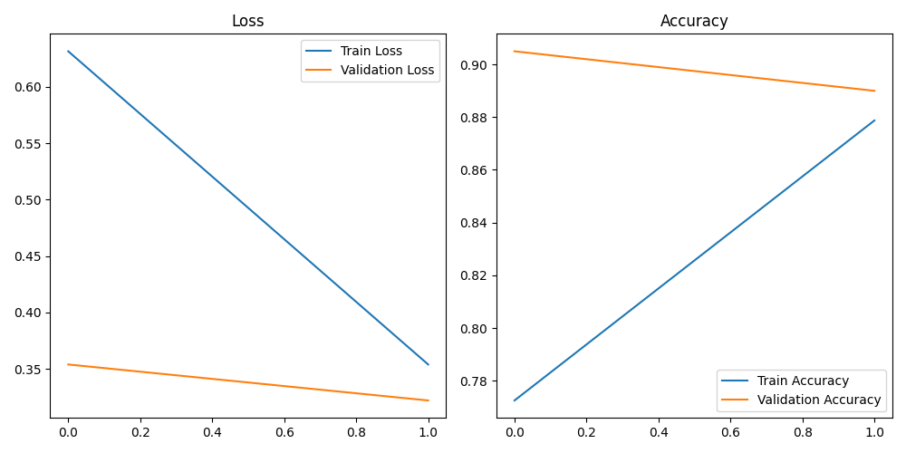
As shown in the figure, the model achieves an overall accuracy of 90% on the validation set. It appears to be a reliable tool for automated sentiment analysis. However, this macro-indicator masks serious flaws in the model at the micro-level, creating a false "illusion of understanding".
4.2 Classification Errors Revealed by the Confusion Matrix
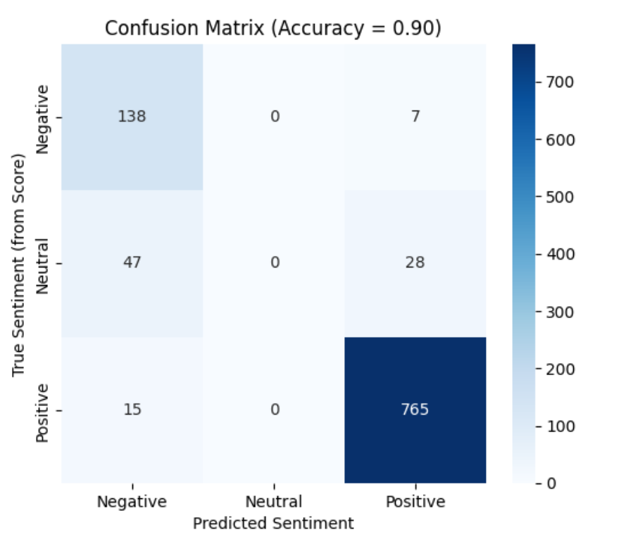
The confusion matrix reveals several critical deficiencies.
First, the model failed to correctly identify any of the "neutral" reviews. Most of the reviews that were truly labelled as "neutral" were incorrectly predicted to be "negative" (47) and some were predicted to be "positive" (28). This is not simply an accuracy issue, but a structural cognitive blind spot in the model. In business practice, 3-star ratings often represent valuable information such as "OK product but room for improvement", "average experience", or "meets expectations but no surprises". This failure of the model means that an entire group of neutral, swinging customers is completely excluded from the decision horizon, and their voices are forced to be distorted by polarized algorithms, preventing the business from capturing key signals of product improvement.
Second, a proportion (5%) of negative reviews are incorrectly labelled as "positive" by the model. This means that some negative customer complaints may be systematically ignored or even incorrectly labelled as "satisfied". This "underreporting" can lead to customer issues being ignored, dissatisfaction festering, and ultimately a small-scale complaint evolving into a public brand reputation crisis, resulting in irreversible customer loss
In addition, he model performs extremely well in identifying "positive" comments (765 correct), which, while pushing up the overall accuracy, suggests that the model may be overlearning the patterns of the majority positive samples in the dataset at the expense of recognition ability on the minority (negative, neutral) categories.
4.2 Semantic understanding gap in word cloud analysis
To explore the basis of the model's decisions, we generated word clouds of positive and negative reviews, further revealing the deeper reasons why the model makes mistakes.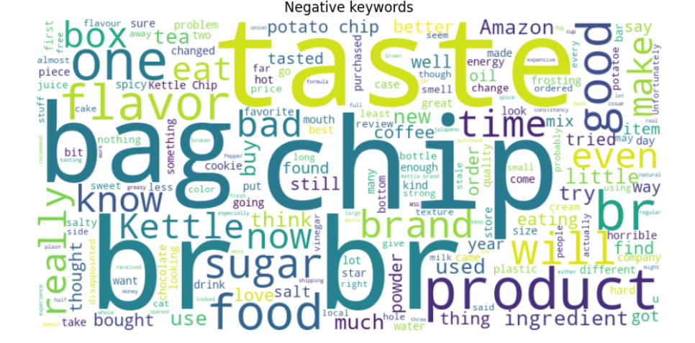
- Negative Keyword Analysis: Prominent words in the word cloud include "taste", "bag", "product", "sugar", "bad", "good". This clearly points to the fact that consumer dissatisfaction is mainly focused on product taste, packaging and overall quality.
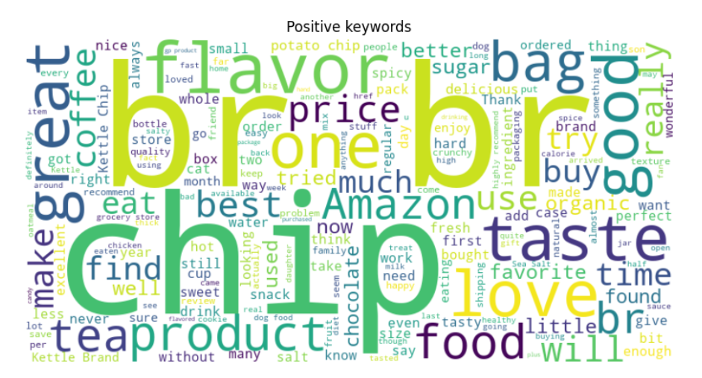
- Positive Keyword Analysis: The word cloud is filled with words such as "love", "great", "taste", "flavor", "chip", "tea" and so on. This suggests that consumer satisfaction comes mainly from the flavor and taste of the product itself.
- Overlap Analysis: It is noteworthy that core nouns such as "taste", "flavor", "chip", and "bag" featured prominently in both word clouds. This confirms our hypothesis that sentiment is not determined by isolated words but by their complex context. This also explains why the model makes mistakes: it may only capture the frequency of keywords, but fails to "understand" their meaning in the specific context.
DistilBERT is powerful, but it‘s still a statistical pattern-based recognizer rather than a real thinker with semantic understanding. It can efficiently associate "great" and "love" with positive emotions, but when it comes to sarcasm like "Great, another broken bag!", implicit contrasts, or complex positive/negative phrases, DistilBERT won’t be able to recognize them. This clearly exposes the huge gap between "pattern recognition" and true "semantic understanding", which hides the truly valuable insights in business.
5. Discussion
  - The Business Risks Behind High Accuracy
The findings of this study point out a risky warning: in business decision-making, a 90% accuracy metric can still be highly misleading. Directly embedding AI sentiment analysis models into business workflows can carry significant risks.
By systematically filtering out negative and neutral feedback, the model can mislead decision-makers into a false sense of satisfaction, causing them to miss crucial opportunities for product and service improvement. What’s more, misclassifying dissatisfied customers as "satisfied" leads to their issues going unresolved. This frustration may eventually erupt on social media or other public channels, inflicting greater damage on the brand's reputation. And the inability to distinguish between neutral suggestions and strong dissatisfaction can lead to the misallocation of limited customer service or operational resources to non-urgent matters.
5.2 Management Strategy Improvement: Building a "Human-in-the-Loop" Business Intelligence Process
Faced with the technical limitations of AI, the appropriate response is not to abandon the technology but to construct a more intelligent and nuanced management framework. AI's value lies in its unparalleled speed and scale, while human value lies in the deep understanding and empathy required to interpret complex and ambiguous information.
Therefore, we advocate for establishing a Human-in-the-Loop business intelligence process:
- AI Initial Screening: Use the sentiment analysis model for a rapid initial screening of massive volumes of reviews, automatically categorizing clearly positive and negative reviews that have very high confidence scores (e.g., >95%) for statistical analysis.
- Intelligent Triage: Automatically route all ambiguous reviews—those classified by the model as "neutral" or those with low-confidence predictions where the model itself is "uncertain"—to human analysts for in-depth exploration.
- Expert Analysis: Have analysts with specialized business knowledge conduct deep-dive interpretations of these "difficult cases" to extract specific insights regarding product design, service processes, logistics, and packaging.
This approach liberates valuable human resources from repetitive classification work, enabling them to focus on the high-value deep analysis that AI can’t perform, thereby turning a technical limitation into a business opportunity.
5.3 Limitations
This study has several limitations.
First, this study exclusively used Amazon food reviews. The linguistic style of this domain (e.g., the frequent use of "taste," "flavor") is unique. Directly applying the model trained in this study to reviews for electronics, fashion, or services would likely result in significantly different performance and error patterns. Furthermore, online reviewers may represent a self-selected group, because users who are either extremely satisfied or dissatisfied are often more inclined to leave reviews, which led to a severe class imbalance in our dataset (80% positive reviews) that directly influenced the model's learning behavior.
Second, the labeling definitions in this study were too simple. Our "3-star = neutral" rule is a heuristic simplification. In reality, a 3-star rating can include complex sentiments such as "well-intentioned criticism," "disappointed but willing to give another chance," or simply "mediocre." This inherent ambiguity and subjectivity in the labels set a natural ceiling on the model's potential performance.
Finally, this study employed only a single model and a basic fine-tuning strategy. It didn’t address the data imbalance through more complex sampling techniques (e.g., oversampling of neutral and negative classes), nor did it conduct a comparative analysis of other models to determine if they offer advantages in handling ambiguous sentiment.
  - Future Work
Based on the findings and limitations of this study, future work can be expanded on several fronts.
On technical level, we can explore more robust models and methods. For instance, we could incorporate "Uncertainty Quantification" techniques, enabling the model to output a "confidence score" alongside its classification. This would provide a more reliable basis for triage in a human-in-the-loop system.
On management application level, the core future challenge is to build and validate efficient human-in-the-loop workflows. This isn’t just a technical problem but also one of organizational behavior and management science. How to design interfaces, train analysts, and smoothly integrate AI insights with human wisdom into the decision-making chain will be key to maximizing the business value of AI.
On social and ethical level, when sentiment analysis is used to measure public reaction to policy, monitor online discourse, or even employee satisfaction, a similar "illusion of understanding" could lead to more severe social consequences. Therefore, promoting the development of "Explainable AI" (XAI) and establishing robust AI auditing and accountability mechanisms will be crucial to ensure that AI technology serves society responsibly and ethically.
6. Conclusion
Through an empirical analysis of the DistilBERT model on an Amazon review dataset, this study reveals that a high-level accuracy metric in sentiment analysis can mask severe functional deficiencies in key segments, particularly for neutral and some negative sentiments. We argue that this "illusion of understanding behind high accuracy" poses a significant risk to business practices that directly adopt AI outputs as a basis for decision-making. The core conclusion of this report is that when applying AI to complex social and business problems, managers and researchers must adopt a critical, socio-technical perspective that goes beyond purely technical metrics. We must deeply understand a model's "capability boundaries" and design organizational and procedural strategies, such as human-in-the-loop systems, to expand its strengths, reduce its risks, and ultimately achieve an effective synthesis of technological power and human wisdom.
References
- Devlin, J., Chang, M., Lee, K., & Toutanova, K. (2018). BERT: Pre-training of Deep Bidirectional Transformers for Language Understanding. ArXiv. https://arxiv.org/abs/1810.04805
- Gogolok, J., & Kowalski, P. (2020). Operators coming from ring schemes. ArXiv. https://arxiv.org/abs/2008.08443
- Sanh, V., Debut, L., Chaumond, J., & Wolf, T. (2019). DistilBERT, a distilled version of BERT: Smaller, faster, cheaper and lighter. ArXiv. https://arxiv.org/abs/1910.01108
- Vaswani, A., Shazeer, N., Parmar, N., Uszkoreit, J., Jones, L., Gomez, A. N., Kaiser, L., & Polosukhin, I. (2017). Attention Is All You Need. ArXiv. https://arxiv.org/abs/1706.03762

